**UML Profile Diagrams**

**Profile diagram** is [**structure diagram**](https://www.uml-diagrams.org/uml-25-diagrams.html#structure-diagram) which describes **lightweight extension mechanism** to the UML by defining custom [**stereotypes**](https://www.uml-diagrams.org/stereotype.html), [**tagged values**](https://www.uml-diagrams.org/stereotype.html#tagged-value), and constraints. Profiles allow adaptation of the UML metamodel for different:

* *platforms*, such as Java Platform, Enterprise Edition (Java EE) or Microsoft .NET Framework, or
* *domains*, such business process modeling, service-oriented architecture, medical applications, etc.

For example, semantics of standard UML metamodel elements could be specialized in a profile. In a model with the profile "Java model," generalization of classes should be able to be restricted to single inheritance without having to explicitly assign a stereotype «Java class» to each and every class instance.

The profiles mechanism is not a first-class extension mechanism. It does not allow to modify existing metamodels or to create a new metamodel as MOF does. Profile only allows adaptation or customization of an existing metamodel with constructs that are specific to a particular domain, platform, or method. It is not possible to take away any of the constraints that apply to a metamodel, but it is possible to **add new constraints** that are specific to the profile.

Metamodel customizations are defined in a profile, which is then applied to a package. [**Stereotypes**](https://www.uml-diagrams.org/stereotype.html) are specific metaclasses, [**tagged values**](https://www.uml-diagrams.org/stereotype.html#tagged-value) are standard metaattributes, and **profiles** are specific kinds of packages.

Profiles can be dynamically applied to or retracted from a model. They can also be dynamically combined so that several profiles will be applied at the same time on the same model.

Graphical nodes and edges used on profile diagrams are: [**profile**](https://www.uml-diagrams.org/profile.html), [**metaclass**](https://www.uml-diagrams.org/profile-metaclass.html), [**stereotype**](https://www.uml-diagrams.org/stereotype.html), [**extension**](https://www.uml-diagrams.org/profile-extension.html), [**reference**](https://www.uml-diagrams.org/profile-reference.html), [**profile application**](https://www.uml-diagrams.org/profile-application.html).

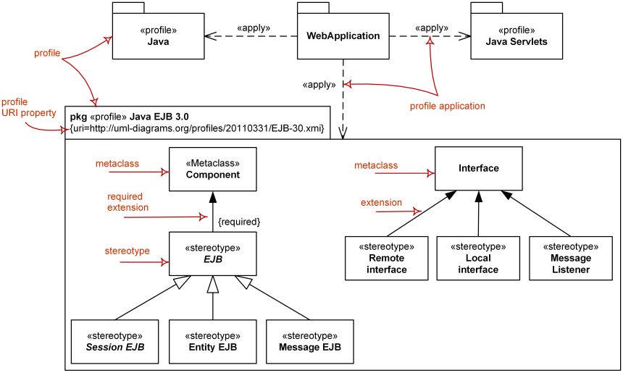

*Major elements of UML profile diagram -*[***profile***](https://www.uml-diagrams.org/profile.html)*,*[***stereotype***](https://www.uml-diagrams.org/stereotype.html)*,****[metaclass](https://www.uml-diagrams.org/profile-metaclass.html)****,*[***extension***](https://www.uml-diagrams.org/profile-extension.html)*,*[***profile application***](https://www.uml-diagrams.org/profile-application.html)*.*